Brine instead of Rock Salt to Protect Water Quality!
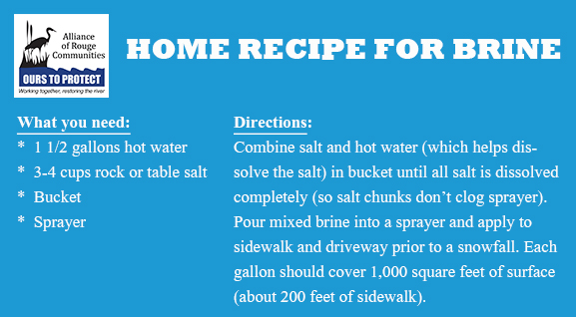
Salt keeps our communities safe, by reducing both the number of vehicle accidents as well as slip and fall accidents. Unfortunately, salt doesn’t just disappear when all the snow melts; it is washed into our lakes, rivers, and streams and has an almost immediate effect on water quality. As a homeowner, consider reducing salt use by applying brine, not rock salt, before a snow storm and shoveling frequently to keep snow from accumulating. This is the best way to save your back, your knees, and the Rouge River!
Brine, a mixture of salt and water, has become a great alternative to traditional rock salt. The transition to using brine for a homeowner has minimal costs. The brine can be pre-mixed in large quantities and stored in your basement or garage. By spraying brine, you have more control over your application, so you don’t apply over the same area twice and it won’t bounce off the driveway the way rock salt can. Brine starts working much faster than rock salt due to the increased contact area with the snow. The best method is to apply the brine before a snow storm begins. Not all communities have transitioned to the use of brine on roads because there is a significant startup cost for additional equipment and storage.

